Practical Work 5: Stics intercrop in practice

We are going to simulate a sorghum-cowpea intercrop in southern Mali. The climate is typical of Sudano-Sahelian zone of West Africa. The soil is classified as Lixisols.
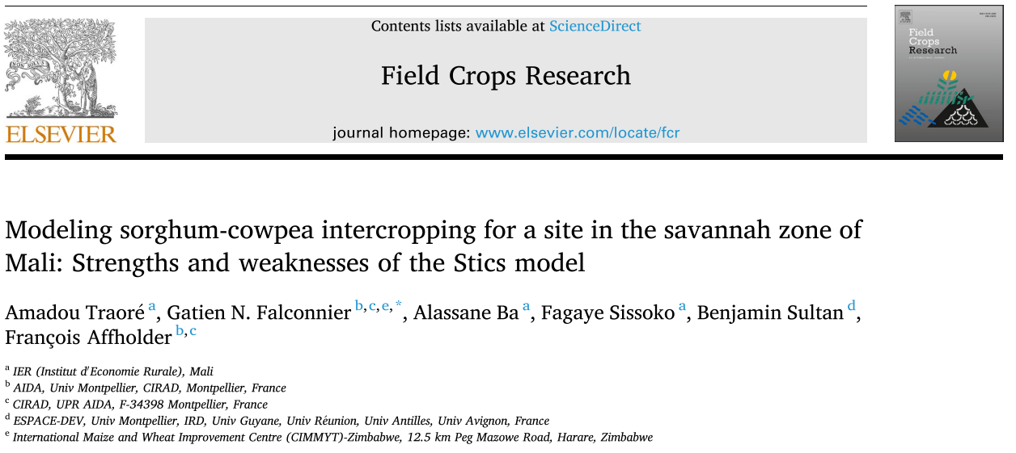
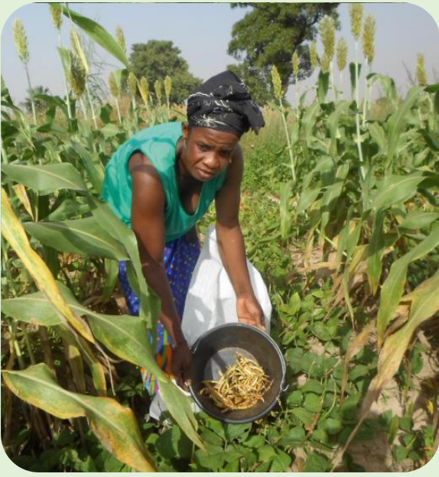
The design is additive.
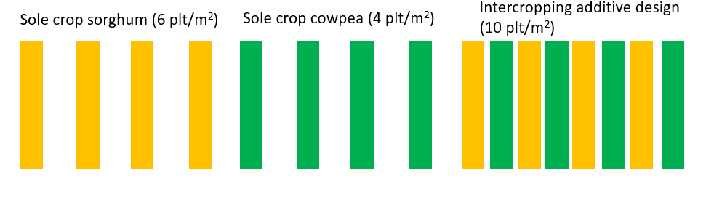

- Compare sole cropping simulatins with simple and complex options
The folder « Simple_formalisms » contains all the required files to run
- a simulation of rainfed sorghum fertilised with 38 Nkg.ha⁻¹, sowing density = 6plt.m⁻² (02NT18SorgV2D1)
- a simulation of rainfed cowpea without fertilisation, sowing density = 4plt.m⁻² (NT18Niebpur)
These simulations use simple formalisms for radiation interception and water requirements. However, if we want to compare sole cropping with intercropping simulations we need to use the same formalisms (radiation transfert and radiative approach).
a. Run both usms with simple formalisms and fill the table in « Practical_Work3.xlsx » based on the mod_name_of_usm.sti file.
b. Compare simple formalisms with complex formalisms in sole cropping simulations by following these steps :
1. Copy the folder « Simple_formalisms » naming it « Complex_formalisms » in your working directory. Open « Complex_formalisms » folder in JavaSTICS.
⚠ Every time you modify a choice in the formalisms of any STICS input file, check that the parameters required for this formalisms are specified and chose the correct value for your situation.
2. Modify plant files:

In each plant file go to the radiation interception module and set radiation interception to “radiation transfers”.
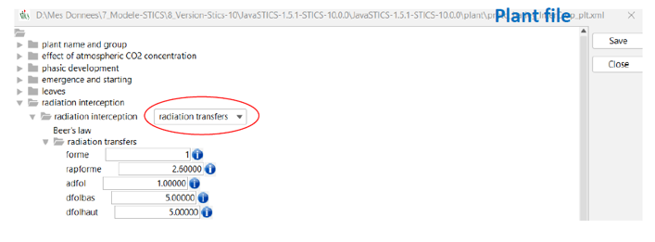
In each plant file go to the water module and set the requirement to “resistance approach”.
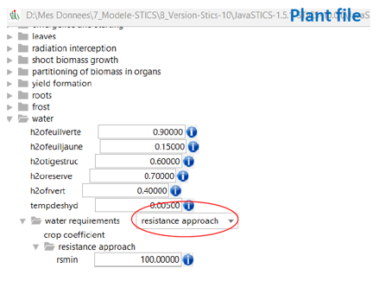
3. Modify technical files:

For each tec file, go to the sowing module and set ‘planting structure’ to yes.
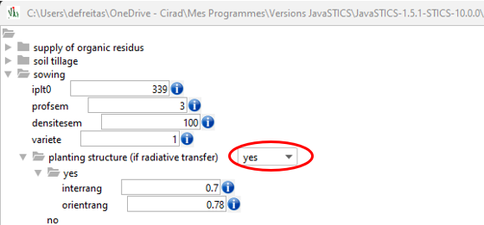
4. Modify station file:
Open the weather station ‘StationNtarla’, open the ‘climate module’ and set reading or calculation of PET to ‘PET_Shuttleworth-Wallace_calculation’.
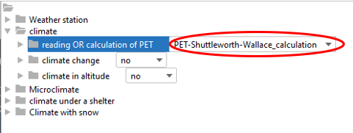
Run both usms with complex formalisms and fill the table in « Practical_Work3.xlsx » based on the mod_name_of_usm.sti file.
- Create intercropping usms
1. Create new initial files:
Open the initialization file “02NT18SorgV2D1_ini.xml”. If you get an error message, ignore it.
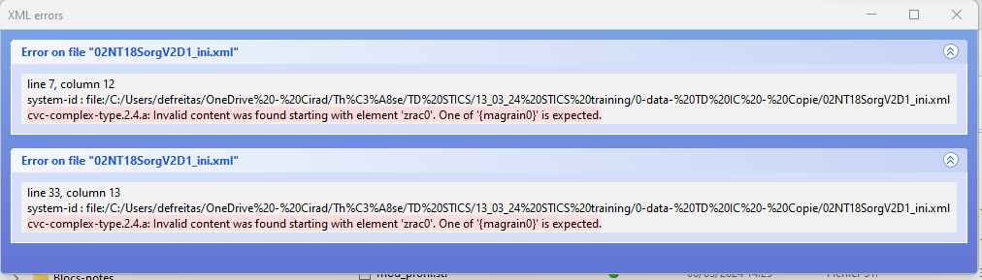
Tick the box ‘Associated plant’. Save as 02NT18SorgV2D1_int_ini.xml.
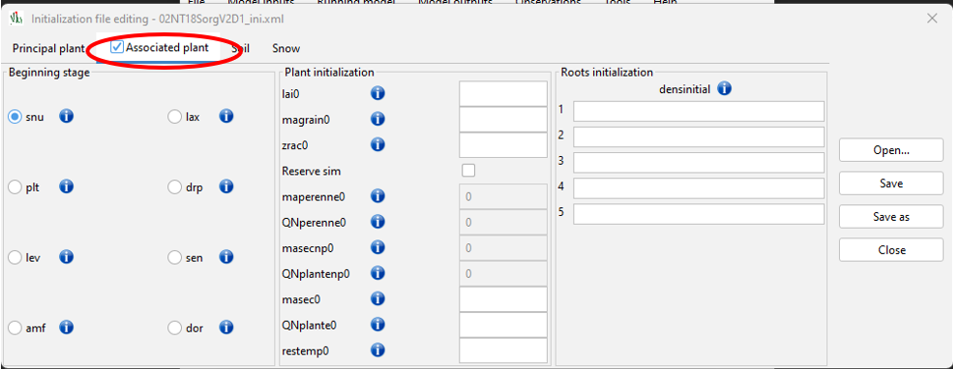
2. Create intercropping usms:
Open the usm of Sorghum “02NT18SorgV2D1”
Tick option intercropping.
Fill associated plant red boxes with the cowpea files.
Change the initialization.
Save as “02NT18SorgV2D1_int”
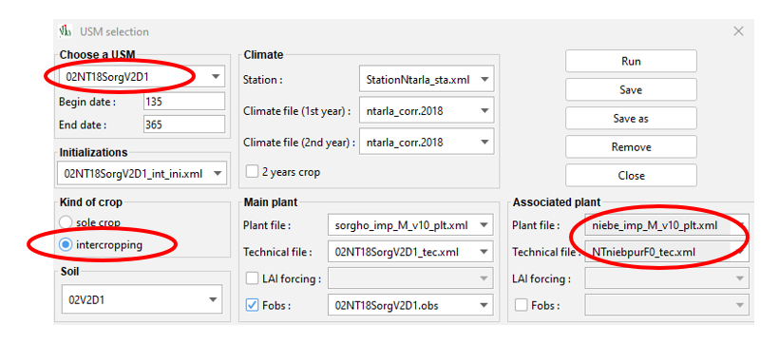
Run the usm and fill the table in « Practical_Work3.xlsx » based on the files mod_bpname_of_usm.sti for principal crop and mod_baname_of_usm.sti for associated crop.
- Impact of different crop managements
1. Impact of fertilization on intercropping performance,
Create new technical files with no fertilization and a high fertilization level (120 kgN/ha) for sorghum.
- Create a new file from 02NT18SorgV2D1_tec.xml
- Rename 02NT18SorgV2D1_F0_tec.xml or 02NT18SorgV2D1_F120_tec.xml
- Replace fertilisation values in the tec files and save.

Create and launch usms with and without fertilization
Compare the new simulations with and without fertilization.
2. Impact of planting date
Create a new technical file for cowpea with a different planting date: 192, later than sorghum (177).
- Create a new file from NTniebpurF0_tec.xml
- Rename NTniebpurF0_PD2_tec.xml
- Replace planting date in the tec file and save.
Create and launch the intercropping usm with sorghum planted day 177 and cowpea day 192.

Do the opposite with cowpea planted day 177 and sorghum day 192.
- Create a new file from 02NT18SorgV2D1_tec.xml
- Rename 02NT18SorgV2D1_PD2_tec.xml or 02NT18SorgV2D1_F120_tec.xml
- Replace planting date in the tec file and save.
Compare the new simulations for the two planting dates.
3. Impact of row spacing and density on simulations
Create a new tec file with larger sorghum row spacing (0.8 instead of 0.4) and lower densities (3 instead of 6).
- Create a new file from 02NT18SorgV2D1_tec.xml
- Rename 02NT18SorgV2D1_RS2_tec.xml or 02NT18SorgV2D1_F120_tec.xml
- Replace row spacing in the tec file and save.
Create and launch the simulations with the new raw spacing for sorghum.

Do the same for cowpea (row spacing of 0.8 instead of 0.4) and lower densities (2 instead of 4).
- Create a new file from NTniebpurF0_tec.xml
- Rename NTniebpurF0_PD2_tec.xml
- Replace planting date in the tec file and save.
Create and launch the simulations with the new raw spacing for cowpea.
Compare the new simulations with the previous ones.
Finally make a simulation with substitutive design:
Additive

Substitutive
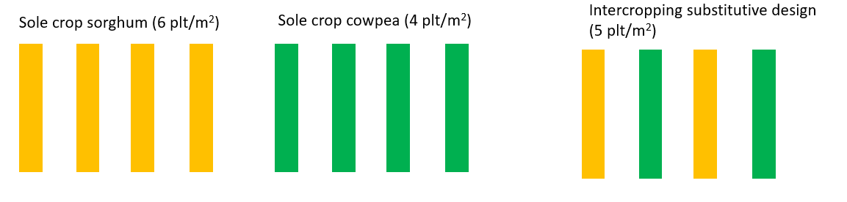
Compare the new simulations with the previous ones.

